Prototype Proof of Concept Plan: Option Period 1
Plan in support of Project Ascend
Contract Number: | HC1084-25-0001
Participant Name: | Scale AI
AOR: | Melissa Redd, melissa.j.redd.civ@mail.mil
Participant POC: | Josiah Cline, josiah.cline@scale.com
Date: | September 16, 2025

Purpose
The objective for Option Period 1 is to expand upon the successful deployment of the Donovan platform by increasing the user base, integrating a live data feed, and developing mutually defined custom workflow applications to align with DISA's mission need. The goal is to mature the prototype from an initial operational capability to a more deeply integrated tool that provides tailored, high-impact solutions for DISA's Defensive Cyber Operations (DCO) mission.

Scope
This plan covers the 6-month Option Period 1 from
August 15, 2025, to February 14, 2026. The scope for this period includes:
- Expanded User Access: Increasing platform access to 200 Donovan accounts on the platform.
- Live Data Integration: Providing the necessary engineering support to connect one (1) live data integration on SIPRNet.
- Custom Workflow Applications: Developing and delivering six (6) mutually agreed-upon custom workflow applications aligned to specific DCO use cases.
- Enhanced Security: Enabling DoD PKI enabled authentication (SIPR Token) for privileged users.
- Sustainment and Support: Continuing to provide software updates, platform sustainment, and the necessary documentation to obtain and maintain the Authority to Operate (ATO).

Solution Overview
Scale’s solution represents a force multiplier to the Global DODIN user base and other DISA stakeholders. Users have different missions and requirements, and have access to different information systems, databases, and knowledge stores that support the completion of their work. Deploying Donovan allows DISA and the three Mission Groups to connect their datasets to Donovan, accelerating information retrieval by placing all relevant data in a centralized location.

Doing so increases throughput and productivity by using the LLM to produce an ~80% complete draft of relevant text, code, and reports. Donovan is flexible with core components and allows DISA users to shape the platform around their use cases. For example, if a particular Mission Group is focused on language translation, they can use models that are particularly trained along certain language types and information encoders that support multi- and cross-lingual information retrieval and proceed to set up workflows that support their specific mission set. Scale’s solution includes the tooling and delivery team required to allow DISA to unlock their own workforce in support of their respective missions.

Donovan is a Generative AI platform that not just leverages multiple Large Language Models but enables Scale to build customer and bespoke workflows for end-users. Via Scale’s industry leading expertise. Via the services component of this contract, Scale will seek out high leverage workflows that will enable Donovan’s users to have an immediate impact with Donovan.

DCO is a wide-spanning field and there are many use cases, from threat hunting and incident response to user education and threat intelligence sharing. Many of these tasks involve some configuration of information retrieval from various sources, data transformation, and a report expressed in language. The benefit of Donovan is extensibility; users will be able to upload datasets specific to their mission and work with Scale to configure unique workflows and apply LLMs tailored to their problem set, all in a secure deployment.

Deploying Technology
During Milestone 1 and 2 Scale will enhance Donovan in DISA’s SIPRNet environment. Scale’s current understanding is that we will be able to utilize DISA’s AWS environment. This has many benefits to Scale and the USG as Scale supports a majority of its current customers on an AWS environment, its core functions and overall user experience are highly optimized around AWS-native features such as EC2, S3, RDS, EKS, and others.

Tactically, via Scale’s facilities in St. Louis, our Infrastructure Engineering team will stand up the platform, perform scans, and allow our Lead Compliance Engineer, Frenchesca Donhaue to submit our IATT/ATO package. However, as of project Kick-Off Scale is blocked from deploying our technology to IATT/ATO.

Scale still requires:
- AWS Test / Dev Accounts,
- Security Controls,
- Data Types,
- Access to DODNet System,
- NIPR/SIPR accounts,
- FIPS 199 Meeting date,
- Determine who is the AWS cloud broker/managed service provider + meeting date.

Without all of these tasks being completed Scale will be blocked from submitting the documentation necessary for IATT/ATO review.

Once these blockers are removed Scale will largely progress in three phases:
- Resource Deployment:
  - EKS and EKS addons
  - Logging capabilities
  - Istio resources
  - Temporal resources
  - Core AWS resources.
- Database Deployment: Focus on MangoDB
- Application Deployment: Includes Scale’s Donovan platform as well as our fine-tuned defense related Large Language Models.

After the deployment is completed to the Test/Dev environment, Scale will proceed to complete the necessary security scans as determined by the security controls and data types agreed upon with the government. Scans could take a longer period of time depending on the resources provided by the Cloud Service Provider in DISA’s SIPR environment.

Once scans are complete, and remediations are completed, Frenchesca Donahue will submit the necessary IATT paperwork to DISA.

Users
Scale’s Donovan solution has already been deployed and used by hundreds of globally dispersed users across SECRET and TOP SECRET environments, therefore representing a high-TRL solution that has been validated in relevant operational environments. Over the course of the Project ASCEND effort, the solution will be deployed into DISA’s specific SIPR environment and connected to the Mission Group’s different datasets. By becoming more closely ingrained with the Government’s systems, and by forward deploying Scale’s personnel to support training, onboarding, and continuous support, Scale will mature the solution into an operational-ready platform ready for production deployment.

Concurrently to the deployment of Scale’s technology to DISA’s SIPR network - Scale will onboard up to 20 users to our DoD IL4 environment. This will allow Scale to replicate what we have done with many of the other user-groups with the three Mission Groups identified by DISA: DISA Global (Scott AFB), DISA INDOPACOM (Hawaii), and DISA Europe.

There are three key-points Scale performs with user groups:
- User Education
- User Interviews / Study and Pain Point Analysis
- Data Interaction Mapping

Scale knows that all four are necessary for the successful deployment of Generative Ai solutions.

First, user education, which is explicitly identified in the PWS, educating users of Generative AI solutions is crucial for maximizing the potential of these powerful tools while mitigating associated risks. As AI technology rapidly evolves, it's essential for users to understand both its capabilities and limitations. Proper education enables users to formulate more effective prompts, interpret results accurately, and recognize potential biases or inaccuracies in AI-generated content.

Next, Interviews/study allow us to learn what users actually care about and where they need to apply the most leverage. Generative AI is a fantastic tool, however like all tools - they are best aligned to certain tasks. By understanding which tasks users need help with, Scale can make assessments on how best to deploy that technology to individuals.

Finally, by understanding how users interact with the data within their problem sets, Scale can tailor make solutions that limit the cognitive overhead with misaligned solutions.

All three are necessary to build and deploy Generative Ai solutions for the USG and all three steps will be done for DISA with the two identified Mission Groups.

Expected Outcomes & Milestones
The work in Option Period 1 is structured around four key tasks designed to deliver expanded capabilities and demonstrate the platform's value.
Task 1: Option Period 1 Kickoff (PWS 6.4.1)
The Participant will hold a kickoff meeting to confirm objectives for the option period, including the scoping of additional custom workflow applications, the plan to get Government approvals for the live data connection, any additional user onboarding, and the success criteria for execution. The key deliverable for this task is the
Option Year Prototype Proof of Concept Plan.
Task 2: Deliver Mutually-Defined Donovan Expanded Capability (PWS 6.4.2)
This is the central effort of the option period, focusing on the development and delivery of six custom workflow applications on SIPRNet. The specifics of these applications will be refined through technical exchanges between the contractor and the Government. The use cases to be completed in Option Period 1 include:
- Use Case 4 - RFI Response: A prototype to search knowledge bases and synthesize information to create a foundational draft for a Request for Information (RFI) response.
- Use Case 5 - Incident Response Review: A tool to analyze Incident Response (IR) tippers and tickets to automatically extract and summarize key threat indicators and actionable intelligence.
- Use Case 6 - Historical Retro Analysis: A capability enabling analysts to use natural language queries against a wide range of historical data sources to reduce research time.
- Use Case 7 - CCIR Decision Support System: A knowledge system using historical reports and doctrine to analyze incidents and automatically determine if they meet Commander's Critical Information Requirements (CCIR) criteria.
- Use Case 8 - Mission Assurance Site Risk Analysis/Ranking: A tool to analyze inspection reports and trouble tickets to rank sites by risk, providing a prioritized list and data for a "heat map" visualization.
- Use Case 9 - INTEL Agent: A system to ingest threat intelligence reports, extract actionable intelligence like Indicators of Compromise (IOCs), and format them for direct use in security tools.
Successful completion is defined by the official acknowledgement by DISA of the availability of these six prototype applications on SIPR.
Task 3: Complete Option Period Demonstration Event (PWS 6.4.3)
At the conclusion of Option Period 1, the Government and the Participant will jointly present a
Buildout Demonstration Event to an operational and executive audience. This event will showcase the progress made, including the new data sources, custom workflows, and the impact of the expanded user base.
Task 4: Dataset Transition Plan Execution (Contingency) (PWS 6.4.4)
Should the Government choose not to exercise the second option period, the Participant will execute the Dataset Transition Plan (DTP). This involves transitioning data from the platform to a mutually agreed-upon destination and performing other necessary platform wind-down efforts. The successful completion criteria will be a written acknowledgement of completion by DISA.

Timeline
Task # | Deliverable | Due Date
6.4.1 | [Option Period 1] Prototype Proof of Concept Plan | 40 weeks after agreement award
6.4.2 | [Option Period 1] Mutually Agreed Donovan Expansion Capability | 64 weeks after agreement award
6.4.3 | [Option Period 1] Closeout Presentation | 64 weeks after agreement award
6.4.4 | [Option Period 1] Dataset Transition Plan | 64 weeks after agreement award

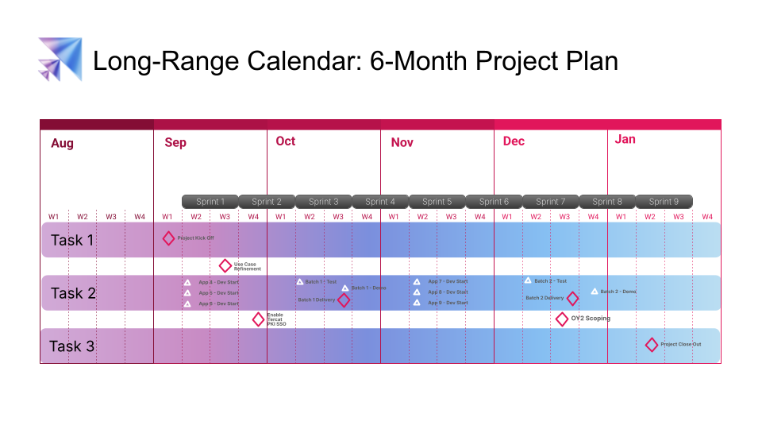

Risks & Mitigations
The risks for this phase shift from initial deployment to integration complexity and user adoption.
Risk | Mitigation
Data Integration Complexity: The live data integration proves more difficult than anticipated, delaying the development of dependent workflow. | Schedule dedicated Technical Exchange Meetings (TEMs) immediately following the kickoff to de-risk the integration and establish clear requirements and timelines.
Use Case Definition Delay: Mutual agreement on the final scope and technical details of the six workflow applications is delayed, impacting the development schedule. | Conduct a series of Joint Application Design (JAD) sessions with DISA stakeholders and mission group users in the first month to rapidly define and approve workflow specifications.
Expanded User Adoption: The expanded user base of 200 may require significant support to effectively adopt the new, more complex workflow applications. | Develop targeted training materials for each new workflow. Assign Scale's Field Engineers to provide proactive, hands-on support and gather feedback.
Infrastructure Performance: New workflows and live data queries increase the computational load beyond the capacity of the current infrastructure, leading to degraded performance. | Conduct performance modeling and stress testing in a development environment before rolling out new capabilities to the full user base. Work with DISA to provision additional resources if bottlenecks are identified.

